**[YourProject] Design Document**

Started on November 17, 2019

**Table of Contents**

**1.** **EXECUTIVE SUMMARY 3**

1.1 Project Overview 3

1.2 Purpose and Scope of this Specification 3

**2.** **PRODUCT/SERVICE DESCRIPTION 3**

2.1 Product Context 3

2.2 User Characteristics 3

2.3 Assumptions 3

2.4 Constraints 3

2.5 Dependencies 4

**3.** **REQUIREMENTS 4**

3.1 Functional Requirements 5

3.2 Security 5

*3.2.1* *Protection 5*

*3.2.2* *Authorization and Authentication 6*

3.3 Portability 6

**4.** **REQUIREMENTS CONFIRMATION/STAKEHOLDER SIGN-OFF 6**

**5.** **SYSTEM DESIGN 6**

5.1 Algorithm 6

5.2 System Flow 6

5.3 Software 6

5.4 Hardware 6

5.5 Test Plan 7

5.6 Task List/Gantt Chart 7

5.7 Staffing Plan 7

# 

# Executive Summary

## ***Project Overview***

The purpose of this project is to have a robot complete an obstacle course in the cleanest way possible. Not bumping into the obstacles. successfully going over a ramp and staying in course

## ***Purpose and Scope of this Specification***

The purpose of this project is to fulfill the requirements of the assignment and assess our skills to work together as a group and organize our plans within this document. The project tests our proficiency with coding, and determines the skill level of each group member with respect to attributes such as teamwork, problem solving and implementation of subjects learned.

# Product/Service Description

In this section, describe the general factors that affect the product and its requirements. This section should contain background information, not state specific requirements (provide the reasons why certain specific requirements are later specified).

## ***Product Context***

* This is our project for CS-104, for the sprint 3 agility section of the robotics project.
* The robot runs on our code created on sphero and a Bluetooth-compatible device(phone).

## ***User Characteristics***

* This program is exclusively used by our group and to be graded by by Professor Eckert

## ***Assumptions***

* The room will be available to test in.
* the room will have an adequate setup allowing the robot to execute code
* The device will be charged.
* The program’s code will work correctly.
* Our devices will function and be able to begin the program
* There will be no malfunction in the robot

## ***Constraints***

Describe any items that will constrain the design options, including

* The robot’s short battery life must be kept in mind.
* The robot requires a long charging time.
* The robot’s testing is limited to one classroom, HH 208

## ***Dependencies***

List dependencies that affect the requirements. Examples:

* Code must function correctly

# Requirements

|  |  |  |  |  |  |
| --- | --- | --- | --- | --- | --- |
| **Req#** | **Requirement** | **Comments** | **Priority** | **Date Rvwd** | **SME Reviewed / Approved** |
| AGIL_01 | The robot must start in the starting area. | The robot will be placed in the starting square. | Priority 1 | 11/20 | Adriel |
| AGIL_02 | The robot must be oriented correctly. | This can be controlled within the robot’s software. With an incorrect orientation, the robot will be off-course the entire time. | Priority 1 | 11/20 | Adriel |
| AGIL_03 | The robot must avoid the first obstacle. | An object will be diagonally to its left. It must roll right past it, with no collision. | Priority 1 | 11/20 | Adriel |
| AGIL_04 | The robot must avoid the second object | An object will be diagonally to its right. It must roll right past it, with no collision. | Priority 1 | 11/20 | Adriel |
| AGIL_05 | The robot must avoid the third object. | An object will be diagonally to its left. It must roll right past it, with no collision. | Priority 1 | 11/20 | Adriel |
| AGIL_06 | The robot must roll over the ramp. | There will be a binder that will act as a ramp. The robot will have to go over it. | Priority 1 | 11/20 | Adriel |
| AGIL_07 | The robot must roll towards the set of pins. | The direction matters, since the following requirement depends on this one. | Priority 1 | 11/20 | Adriel |
| AGIL_08 | The robot must tumble all of the pins. | The speed is important within this requirement. | Priority 1 | 11/20 | Adriel |
| AGIL_09 | While remaining in course | The coding is important, How long, how fast, and degree | Priority 1 | 12/1 | Jefrin |
|  |  |  |  |  |  |

## ***Security***

### **Protection**

* The code is stored within Adriel’s sphero account, and is only accessible to the group.
* This code is only to be submitted through classroom and graded by Professor Eckert.

# System Design

This section will provide all details concerning the technical design, staffing, coding, and testing the system

## ***Algorithm***

* Connect Sphero to compatible device through Bluetooth
* Align and position robot properly
* Execute program
  + Roll towards first glass and pass on left
  + Roll towards second glass and pass on right
  + Roll towards final glass and pass on left
  + Roll with sufficient speed to roll over the binder ramp
  + Roll towards the marker pins and knock over all of them.
* End program.

## ***System Flow***



## ***Software***

* This program will be developed using Sphero's software, which is based on the coding language C.

## ***Hardware***

* This program revolves around the use of a computer or smartphone to store the code and run the program. It also requires the robot, of course.

## ***Test Plan***

|  |  |  |  |  |  |
| --- | --- | --- | --- | --- | --- |
| **Reason for Test Case** | **Test Date** | **Expected Output** | **Observed Output** | **Staff Name** | **Pass/Fail** |
| Check if the robot would pass the first glass. | 11/22 | The robot will roll right next to it. | It ran into the glass. The angle in which it rolled will need to be adjusted. | Adriel, Jefrin | Fail |
| Check if the robot would pass the first glass. | 11/22 | The robot will roll right next to it. | With some code adjustments, it succeeded. | Adriel, Jefrin | Pass |
| Check if the robot can pass both the first and second glass. | 11/22 | The robot will pass by both glasses. | The robot managed to successfully pass by both. | Adriel, Jefrin. | Pass |
| Check if the robot can pass all three glasses. | 11/22 | The robot will zig-zag through the three obstacles. | It ran into the third glass. The rolling angle will be adjusted. | Adriel, Jefrin | Fail |
| Check if the robot can pass all three glasses. | 11/22 | The robot will zig-zag through the three obstacles. | It went in the wrong direction when trying to pass the third glass. The angle will be adjusted. | Adriel | Fail |
| Check if the robot can pass all three glasses. | 11/22 | The robot will zig-zag through the three obstacles. | It successfully weaved through the glasses. | Adriel | Pass |
| Check if the robot can roll over the binder ramp. | 11/22 | The robot will roll over the ramp and gently land. | It missed the ramp. | Adriel | Fail |
| Check if the robot can roll over the binder ramp. | 11/22 | The robot will roll over the ramp and gently land. | With an adjustment to the angle, it successfully rolled over the ramp. | Adriel | Pass |
| Check if the robot can roll into the marker pins. | 11/22 | It will roll towards the markers and knock them down. | It rolled past them. The code from the binder ramp must be adjusted in order to be properly positioned towards the markers. | Adriel | Fail |
| Check if the robot can roll into the marker pins. | 11/22 | It will roll towards the markers and knock them down. | It rolled towards the markers, but only managed to knock down two. More adjustments are necessary. | Adriel | Fail |
| Check if the robot can roll into the marker pins. | 11/22 | It will roll towards the markers and knock them down. | The robot succeeded in knocking down all the “pins”, like a strike. | Adriel | Pass |
| Check if the robot can complete the course the whole way through | 11/22 | It will complete the course. | It almost does. It misses the binder. | Adriel | Fail |
| Check if the robot can complete the course the whole way through | 11/22 | It will complete the course. | It passes the glasses and rolls over the ramp, but only knocks over six markers. Variables such as alignment, floor creases, and the position of the rubber cover alter the sprint every time. This is as good as it is going to get. | Adriel | Pass |

## ***Task List/Gantt Chart***

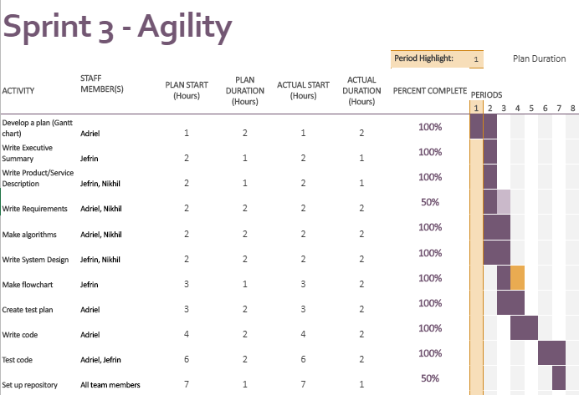

## ***Staffing Plan***

Insert a chart/table that depicts the roles and responsibilities of each team member that worked on this project

|  |  |  |
| --- | --- | --- |
| **Name** | **Role** | **Responsibility** |
| Adriel Juarez | Planner, Programmer | * Create Gantt chart * Write requirements * Write algorithms * Write code * Test Code |
| Jefrin Rivera | tester, corrections, ideas, proofreading. | * Gantt chart * Helped with testing * gave comments, ideas for code |
|  |  |  |